SUMMERVILLE CREDIT UNION · CONSOLIDATED MEMBER GUIDE · CSUM-21 of 30
Skip-A-Pay

Module: nFinia Digital Banking > More > Skip A Pay
Sources: Summerville Reports Series A (36 docs) + Series B (25 docs) | Features: nFinia Documentation Features Spreadsheet
01 PRODUCT SUMMARY

Skip-A-Pay is a member financial relief feature that allows eligible members to formally defer one loan payment per eligible period without incurring a late fee. The deferred payment is posted to the loan account, the loan term is extended by one month, and interest continues to accrue during the skipped month.
The digital Skip-A-Pay workflow replaces paper or phone requests with a fully self-service in-app process. Members select the eligible loan, review the terms of the deferral, accept the agreement, and submit — all within a few steps. The Skip Payment Form in the Online Forms section provides an alternative access path for members who prefer the forms workflow.

At a Glance

Attribute | Detail
Module | More > Skip A Pay
Eligible Loans | Qualifying consumer and auto loans per CU eligibility rules
Effect on Loan | One payment deferred; interest continues to accrue; term extended
Fee | Nominal processing fee may apply per CU policy
Frequency | Once per eligible period per loan (typically once per 12 months)
Related Reports | CSUM-14 (Loan Payments), CSUM-18 (Online Forms)

02 KEY USE CASES

Use Case | Who Uses It | What They Do | Business Value
Holiday Cash Relief | Members needing extra funds during holidays | Skip December payment to free up holiday budget | Maintains loan standing while managing seasonal cash flow
Emergency Expense Cover | Members facing unexpected financial need | Defer loan payment to cover immediate emergency expense | Avoids late fee while managing short-term cash flow disruption
Seasonal Income Gap | Members with seasonal employment | Skip payment during low-income month | Aligns payment obligation with income cycles

03 STEP-BY-STEP GUIDE

Navigation: Dashboard > More > 'Skip A Pay'.
Step 1 — Start from Dashboard
The member begins at the Dashboard after logging in. The Dashboard displays all account balances, upcoming payments, quick-action tiles, and the top navigation bar with links to Accounts, Move Money, and More.
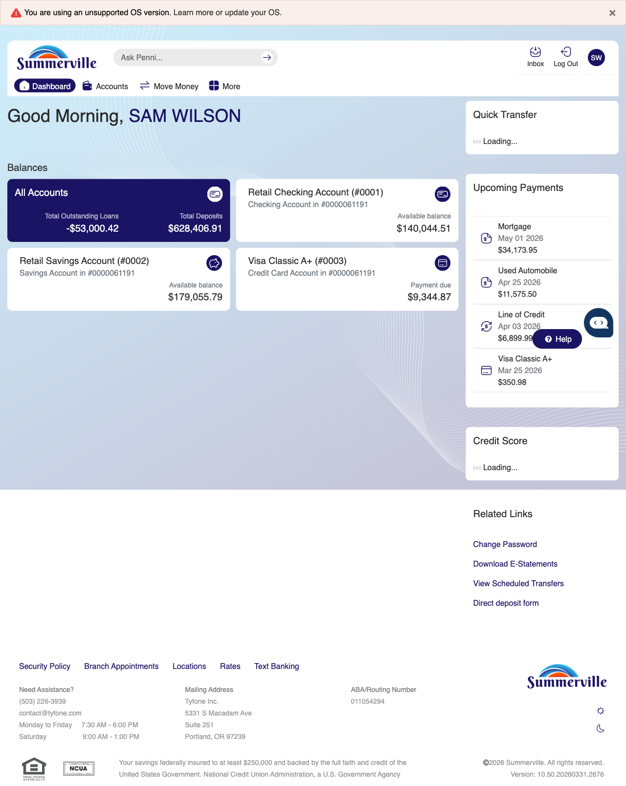
Step 1: Start from Dashboard

Step 2 — Open the More Menu
The member clicks ‘More’ in the top navigation bar. The More options panel expands to show additional features: Check Deposit, User ID and Password, eDocuments, Account Alerts, General Alerts, Password, Forms, One-Time Passcode, Skip A Pay, Do-Not-Disturb, Manage Devices, My Insights, Alert Settings, Recent Activities, and Card Services.
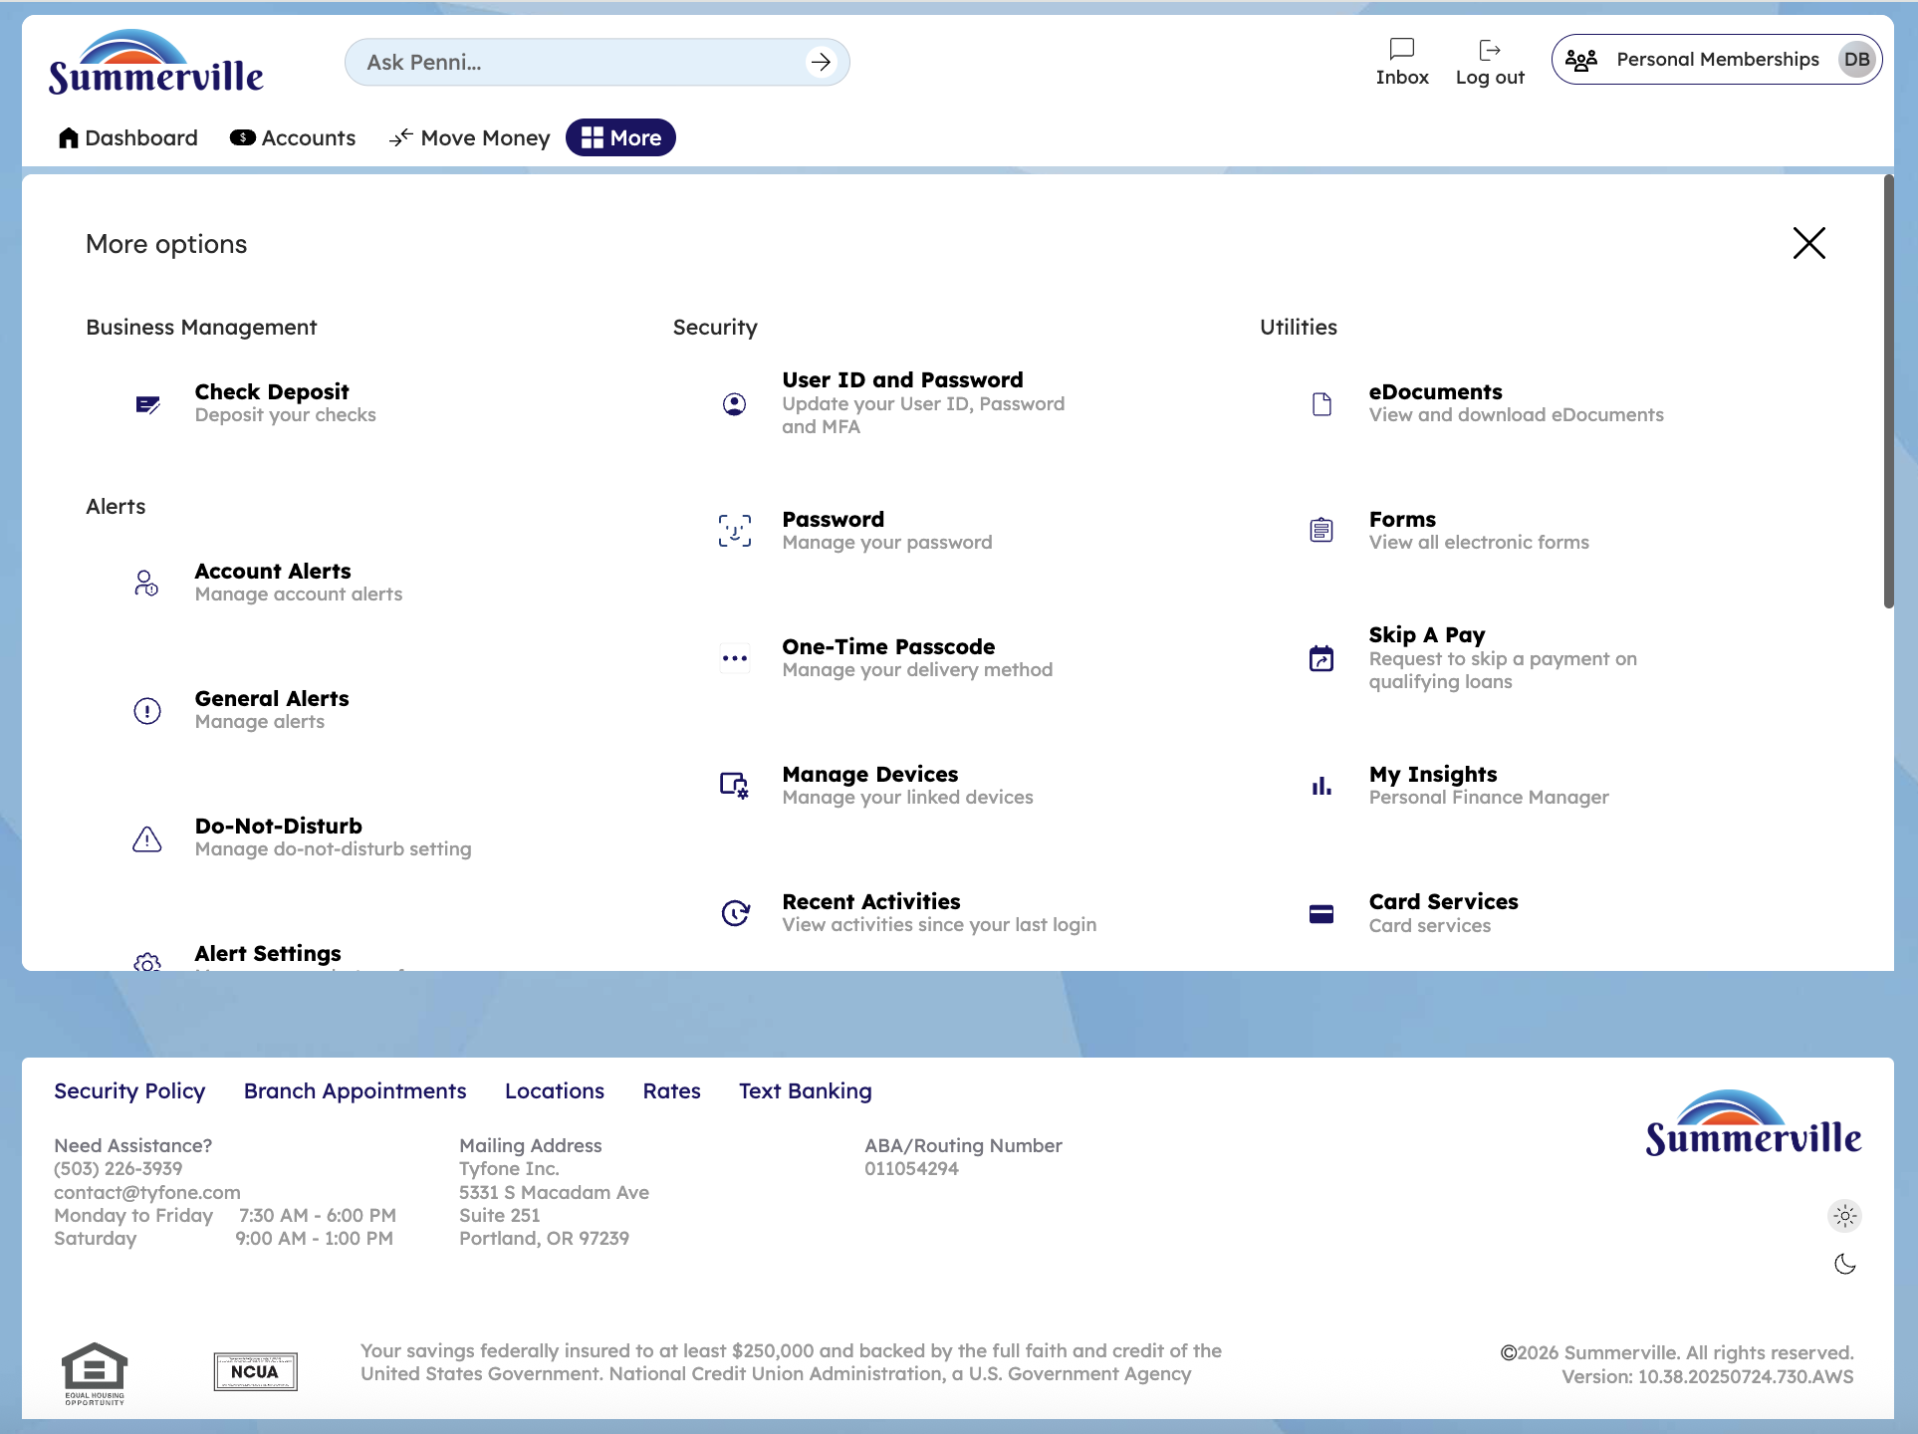
Step 2: More Menu

Step 3 — Navigate from Dashboard to Skip A Pay
The Skip A Pay page shows the selected loan with a current due date of April 2026 and an advanced due date of May 2026. A $35.00 transaction fee is displayed for the skip payment service.
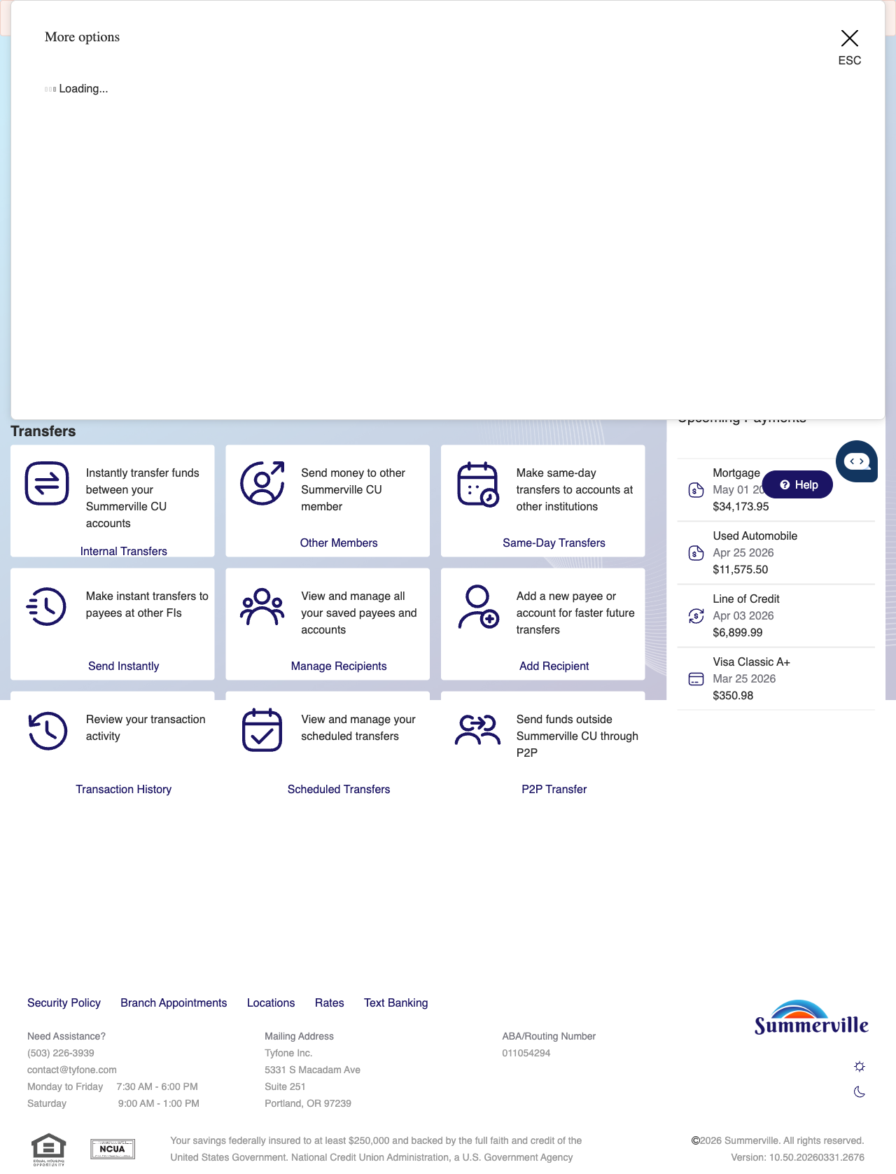
Step 3: Navigate from Dashboard to Skip A Pay

Step 4 — Select Loan & Review Fee Details
The Skip A Pay confirmation page displays details about the selected loan, the fee structure, payment method options, and a terms and conditions checkbox that must be accepted before proceeding.
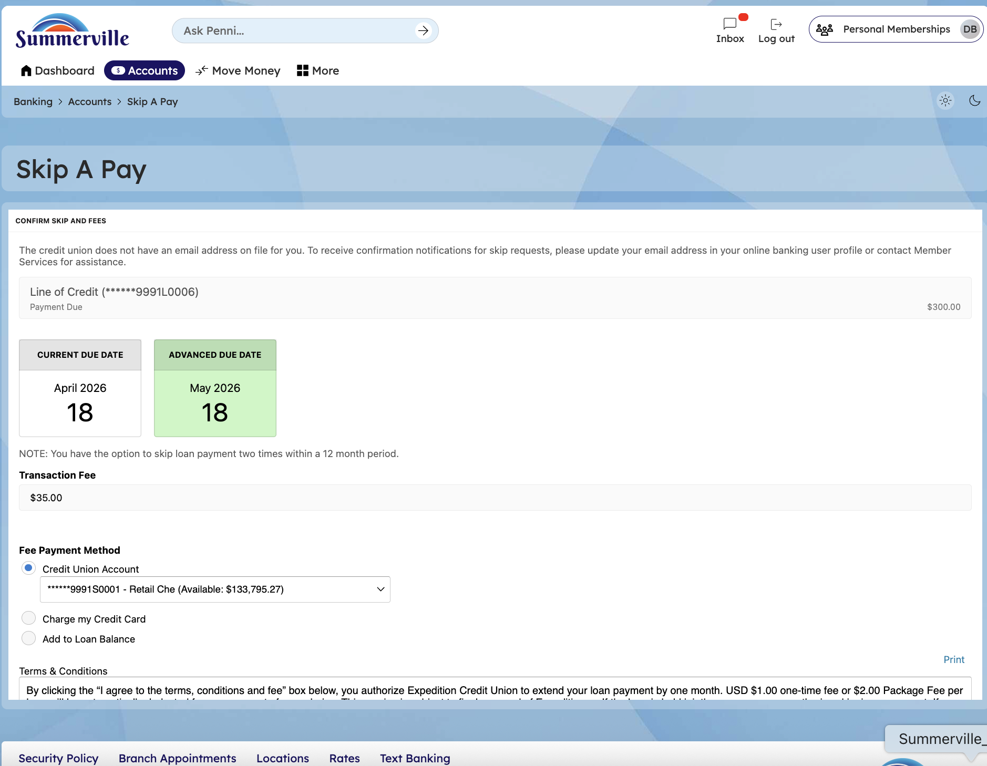
Step 4: Select Loan & Review Fee Details

Step 5 — Accept & Confirm Skip
A confirmation screen states 'Your request for a skip payment has been processed' with a Continue button to return to the main interface.
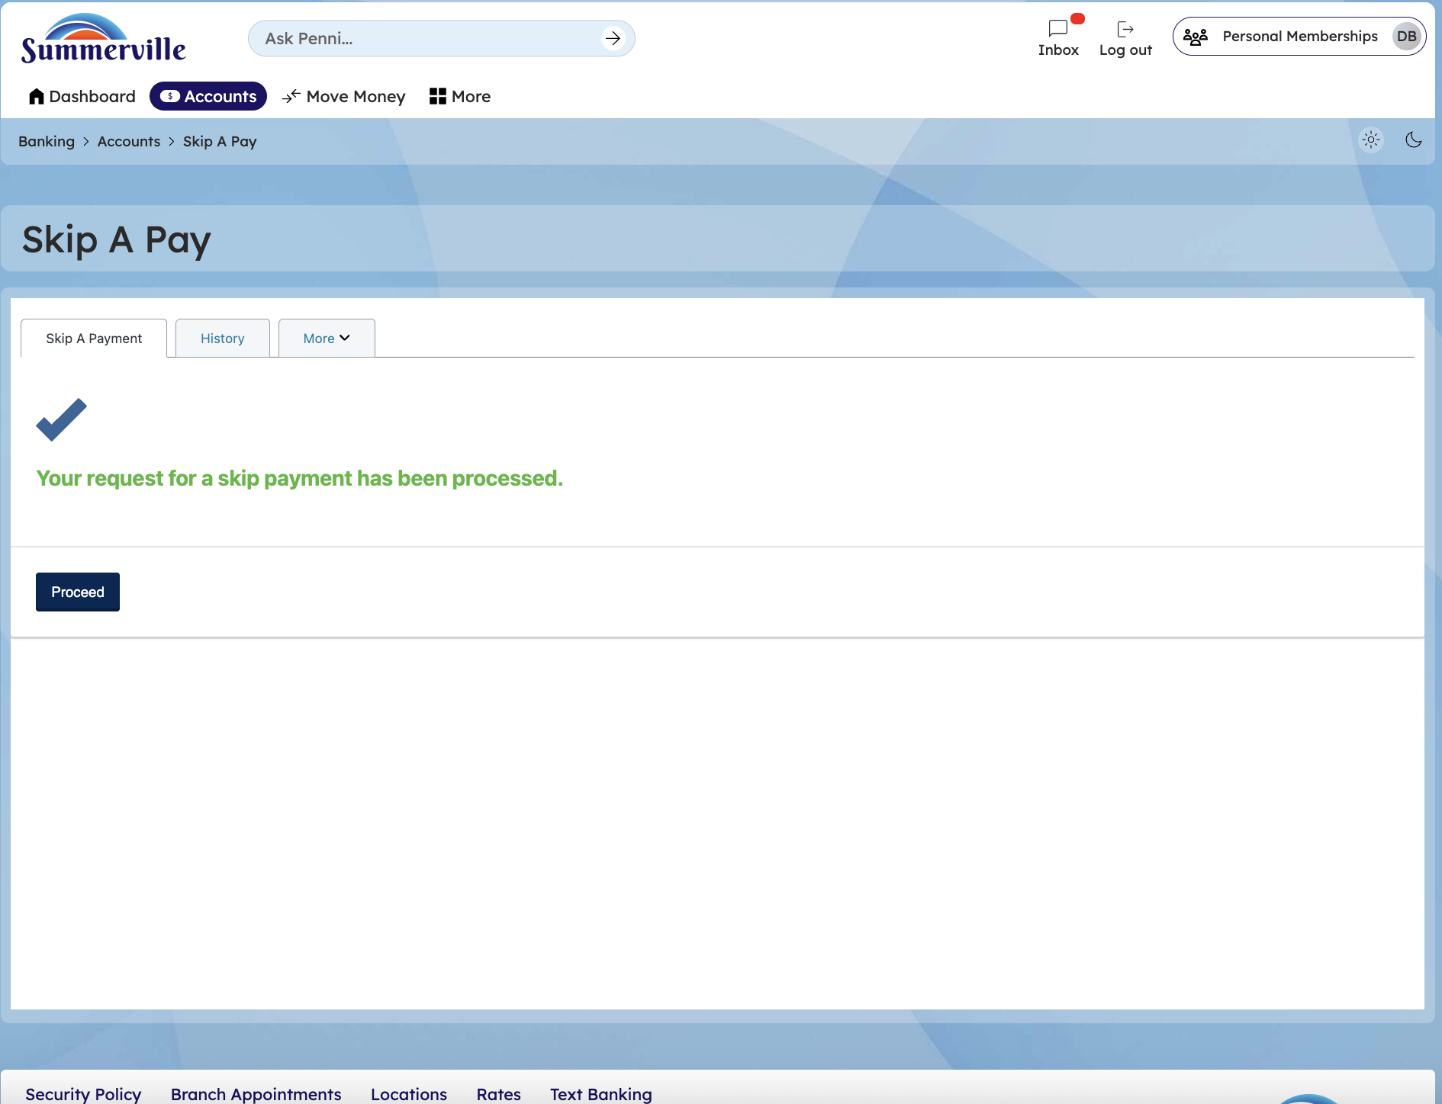
Step 5: Accept & Confirm Skip

